AI-Enhanced Pharmacy Procurement

Taha H. Ababou, Manuel Segimón, Joel Akerman, Bora Bulut, Zaiyan Muhammad

**Abstract**—Most pharmacy procurement systems nowadays involve manual order placements and inventory updates, which is time consuming and often results in overstocking and stockouts. To eliminate this problem and make the process more efficient, we propose an AI enhanced pharmacy procurement system. The project will be based on a machine learning model that will be trained using historical purchase data, taking into account drug package sizes and their availability. It will then automatically find the optimal amount of medication to order while considering alternatives. With a simple UI and user-centered design, the system will consist of four parts: a responsive dashboard designed using ReactJS on the front-end, a Flask-powered Python-based backend, a secure SQL database, and a TensorFlow and Keras-backed ML model. With this project, we aim to maintain optimal inventory levels, save time and cost, and ensure uninterrupted patient care.

**Index Terms**— Artificial Intelligence, Machine Learning, Optimization, Procurement

————————————————

* *Taha H. Ababou is with the Department of Electrical and Computer Engineering, Boston University, Boston, MA 02215. E-mail: hababou@bu.edu*
* *Manuel Segimón is with the Department of Electrical and Computer Engineering, Boston University, Boston, MA 02215. E-mail: manuelsp@bu.edu*
* *Joel Akerman is with the Department of Electrical and Computer Engineering, Boston University, Boston, MA 02215. E-mail: akermanj@bu.edu.*
* *Bora Bulut is with the Department of Electrical and Computer Engineering, Boston University, Boston, MA 02215. E-mail: bbulut@bu.edu.*
* *Zaiyan Muhammad is with the Department of Electrical and Computer Engineering, Boston University, Boston, MA 02215. E-mail: monem@bu.edu*

—————————— ◆ ——————————

# 1 Need for this Project

In the intricate landscape of healthcare, the procurement of pharmaceuticals emerges as a pivotal function that intertwines the realms of logistics, regulatory adherence, and the paramount objective of delivering quality patient care. The proposition at hand revolves around the conceptualization and development of an Artificial Intelligence (AI) system dedicated to refining and augmenting the process of pharmaceutical procurement. This initiative particularly addresses the multifaceted challenges associated with the replenishment of medicine stocks from an array of suppliers, each with distinct operational and supply paradigms.

The primary motivation driving this endeavor stems from a customer-centric perspective, where the end recipient of the pharmaceutical supply chain—the patient—stands at the core of the procurement equation. The health and well-being of patients are significantly impacted by the availability of requisite medicines. This project aspires to alleviate the risks associated with stock-outs by intelligently orchestrating procurement operations based on real-time demand analytics and supplier availability assessments. Furthermore, by automating the procurement procedure and pinpointing the most cost-effective supplier configurations, the AI system holds promise in contributing to the containment of healthcare costs, a benefit that resonates with the financial concerns of patients.

Transitioning the lens to the user—procurement managers and pharmacists—the AI system is envisioned to serve as a robust tool for informed decision-making. The system is designed to dissect and analyze a plethora of supplier data encompassing pricing structures, batch size stipulations, and the availability of alternative product options. This analytical capacity is anticipated to empower users with the insights necessary to optimize procurement strategies, thereby reducing the administrative burden associated with routine procurement tasks. The resultant time savings afford healthcare professionals the latitude to engage in more strategic, value-added activities.

On a broader spectrum, the public health domain stands to gain from a resilient and transparent pharmaceutical supply chain. In the event of public health exigencies or unforeseen supply chain disruptions, an intelligent procurement system can be a linchpin for maintaining supply chain resilience. This resilience, in turn, underpins broader public health stability. Furthermore, the maintenance of a data-driven, transparent procurement process resonates with regulatory compliance mandates and nurtures trust within the communities served.

In summation, the exigency for advancing the pharmaceutical procurement process, rendering it more responsive, efficient, and in harmony with overarching goals of superior healthcare provision, economic sustainability, and societal well-being, fuels this project. By harnessing the capabilities of AI technology, the project endeavors to concoct a robust solution adept at navigating the nuanced challenges intrinsic to pharmaceutical procurement. This initiative, therefore, is poised to play a significant role in propelling forward the domains of healthcare logistics and public health outcomes.

# 2 Problem Statement And Deliverables

## 2.1 Problem Statement

Hospital pharmacies often grapple with drug shortages, necessitating complex and nuanced buying decisions. Buyers must consider factors such as package sizes, availability of drugs, potential alternatives, and cost constraints, among others. This often requires in-depth understanding and experience, making it challenging to train new buyers quickly. Furthermore, reliance on individual expertise may lead to inconsistencies and inefficiencies in the procurement process.

## 2.2 Societal Impact

The societal impact of efficient pharmaceutical supply management is immense and touches various aspects of our lives. First and foremost, it directly influences patient health and well-being. Prompt access to medications and treatments is essential for maintaining and improving individual health. Delays or disruptions in the pharmaceutical supply chain can lead to deteriorating health conditions, posing a serious risk to patients.

Moreover, through this automated system, healthcare institutions can optimize their resources and minimize wastage. This leads to cost savings that can be reinvested in patient care, research, and other critical healthcare initiatives. Following this, as healthcare institutions become more cost-efficient, the savings can potentially be passed on to patients in the form of reduced healthcare costs. This, in turn, makes healthcare more accessible and affordable for a broader section of society.

The automation of routine procurement tasks allows pharmacy staff to focus on more value-added activities, such as patient counseling, education, and engagement. This not only leads to better patient experiences but also enhances the professional fulfillment of pharmacy employees.

## 2.3 Deliverables

This project consists of making an AI driven system that will generate well-informed and timely procurement orders that will purchase alternative products when the primary choice is unavailable. The system will be analyzing historical purchase data and decisions made by trained personnel when placing orders for alternative medications.

Some of the deliverables will be the following:

### 2.3.1 Data Collection and Analysis

The first phase of the project involves comprehensive data collection and analysis. This encompasses gathering past data, current trends, demand, and supplier details.

### 2.3.2 AI Model Development

In the second phase, the focus shifts towards the development of machine learning models to optimize the procurement process. These models are designed to determine the optimal quantities for procurement based on the extensive data collected during the previous phase. The development process includes documenting the AI model(s), which involves specifying the algorithms used, setting parameters, and detailing the methodology employed for model training.

### 2.3.3 User Interface

An integral aspect of this project is the creation of a user-friendly interface for effective interaction with the AI-powered procurement system. The system will have an intuitive dashboard that is easy to interact with for human overseers to monitor, override, or tweak system recommendations.

### 2.3.4 Integration

The final phase of the project focuses on ensuring seamless integration with external systems. This involves the provision of Application Programming Interfaces (APIs) that allow for the exchange of data and information between the AI-powered procurement system and other relevant systems. Specifically, we will be combining the hospital’s internal OmniCell data with external wholesaler APIs, enabling a smooth transfer of information between parties.

### 2.3.5 Feedback Loop

In a pharmacy environment, real-time scenarios can be unpredictable. Market fluctuations, sudden changes in patient needs, and unforeseen events (such as disease outbreaks or natural disasters) can impact the procurement process. To address this, the system will learn and optimize itself through human adjustments and real-time scenarios.

# 3 Visualization

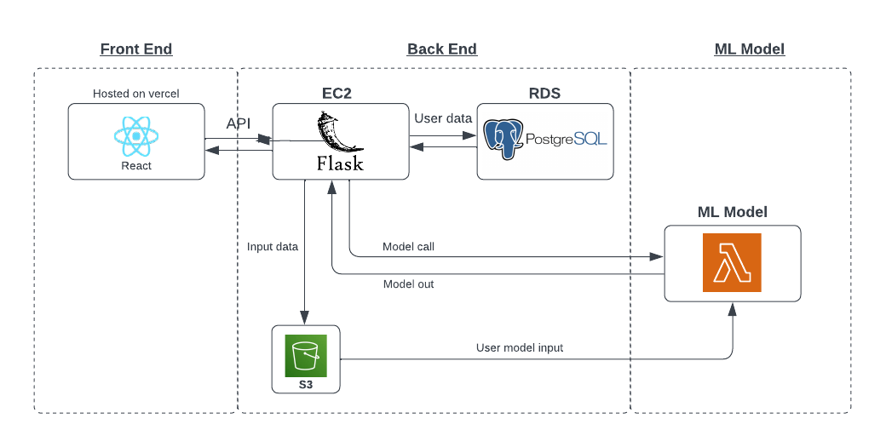

Fig. 1. This image shows the overall architecture of the application.

The flow diagram above (Fig. 1) visually illustrates the system architecture, offering a comprehensive look at the seamless integration of the front-end, back-end, and machine-learning model components, all geared toward optimizing pharmaceutical procurement.

The system's front end is developed using the React framework, known for its efficient and flexible user interface capabilities. Hosted on Vercel, the React deployment ensures users experience a responsive and intuitive interface. Vercel is renowned for its optimal performance, scalability, and developer-friendly environment.

The back end serves as the nexus of the system, seamlessly linking the user interface to the database and the core machine learning model. At the heart of the back-end is a Flask API, designed to efficiently manage data exchanges between the front-end, the databases, and the predictive model. This component resides on an Amazon EC2 instance, chosen for its reliability and adaptability to varying demands. The system leverages a PostgreSQL database hosted on the Amazon RDS platform for user data storage. It's imperative to note that the primary data feeding the machine learning model, encompassing, but not limited to, current inventory metrics and supplier information, is stored within an S3 bucket. This ensures that the model always has access to up-to-date information when making procurement predictions.

Diving deeper into the system's core, the machine learning model is where data processing and analysis occur. The model is encapsulated within an AWS Lambda function to optimize its efficiency and future-proof the system. Lambda, a serverless computing service, allows for easy versioning and updates, thus offering enhanced flexibility and reduced operational overhead. This model is triggered by the Flask back-end whenever procurement-related decisions are necessary. Once activated, the Lambda function fetches the latest data from the S3 bucket, processes this data, and subsequently provides the output.

# 4 Competing Technologies

The landscape of pharmaceutical procurement is gradually being transformed by AI and ML technologies. Notable examples include the AI implementation at RWJBarnabas Health and the AI-powered procurement solutions by Arkestro.

RWJBarnabas Health's AI software aids in efficient inventory management and anticipates a 5% to 10% annual cost savings through informed procurement decisions​ [1]. On the other hand, Arkestro's "intelligent first offers" system streamlined procurement processes at a multinational biopharmaceutical company, enabling quicker quote requests from suppliers and resulting in a significant 13.68% savings over baseline on their final award outcome [2]​.

Furthermore, AI-driven predictive analytics are being utilized to determine optimal restocking times based on existing stock levels and demand patterns, emphasizing the importance of real-time data analytics in procurement​ [3]. General AI applications in Supply Chain Management, although broader, showcase the potential of AI in optimizing supply chain processes, including pharmaceutical procurement​ [4].

These technologies underscore key requirements such as real-time analytics, user-friendly platforms, centralized communication, and predictive capabilities, which are crucial for our AI-driven pharmaceutical procurement project.

# 5 Engineering Requirements

The requirements specified for the implementation of the AI procurement application include the following:

1. The platform will have a cloud based architecture.
2. Generate optimal procurement quantities using collected data.
3. Integrate diverse data sources such as historical purchases and medication trends.
4. Design a user-friendly interface for pharmacy staff.
5. Enable electronic dispatch of orders to drug wholesalers.
6. Ensure compatibility with existing pharmacy automation systems.
7. Integrate seamlessly with drug wholesaler platforms.
8. Achieve interoperability with third-party accumulators.

**Acknowledgment**

The authors wish to thank Professor Osama Alshaykh and Gordon Hubbard of the Beth Israel Deaconess Medical Center for their continuous support throughout the project.

**References**

[1] G. Ledger, “Facing Pharmaceutical Supply Challenges With Artificial Intelligence,” HealthTrust - Performance Improvement For Healthcare, Feb. 01, 2021. https://healthtrustpg.com/thesource/cqo/clinically-integrated-supply-chain/facing-pharmaceutical-supply-challenges-with-artificial-intelligence/ (accessed Oct. 20, 2023).

[2] Arkestro, “Global pharma firm leverages AI first offers to drive savings and shorten cycle time,” Arkestro, Mar. 13, 2023. https://arkestro.com/case-studies/global-pharma-firm-leverages-ai-first-offers-to-drive-savings-and-shorten-cycle-time/ (accessed Oct. 20, 2023).

‌[3] “7 Ways AI is Transforming Procurement in Healthcare,” *Vamstar*. https://vamstar.io/my-resources/7-ways-ai-is-transforming-procurement-in-healthcare/ (accessed Oct. 20, 2023).

‌[4] D. Owczarek, “Inefficiencies in pharmaceutical supply chain cost. Leveraging AI in drug supply chain management - nexocode,” nexocode, Mar. 30, 2021. Available: https://nexocode.com/blog/posts/ai-in-drug-supply-chain/

‌